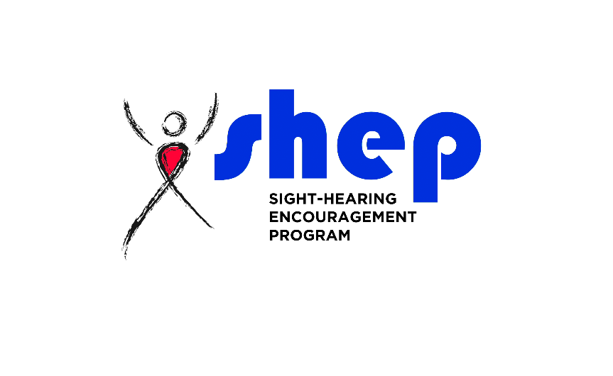
SHEP 2018 Deaf-Blind Symposium Registration Form
Sequoyah Lodge in Wagoner, OK

SSP or Observer REGISTRATION FORM

All campers must be 18 years or older
You can pay by PayPal, Credit Card, Money Order, or Check.
Payment option will be at end of form.

SHEP 2018 Deaf-Blind Symposium
WHEN: Thursday, October 18, 2018 at 3:00 P.M.
until Sunday, October 21, 2018 at 11:00 A.M.

WHERE: Sequoyah State Park Lodge
19808 Park 10
Hulbert, OK 74441

COST:
$200.00 - Observers
$50.00 Volunteer SSPs

THEME: ‘Deep Water’ – Slogan is “Cast your net; Grab opportunities!”
TRANSPORTATION: To be announced later
ACTIVITIES: Fun Games, Horseback Riding, Submarine Tour, Workshop, Social Time, Saturday Night Party
If you need more information about the Symposium, please email Cassandra Oakes at cassandra@shep-ok.org
Deadline will be on September 18, 2018
A confirmation letter with more information will be sent at a later date.
IMPORTANT ATTENTION:
If you are paying by check or money order, payment must be in no later than September 18, 2018
You can mail check or money order to:
SHEP
Attn: Cassandra Oakes
4917 Portland Ave
Oklahoma City, OK 73112

Full Name: ________________________________________________
Address: _____________________________________
City: __________________________________________
State: _________________________ Zip: _______________
Phone Number: ____________________________________
Email: ____________________________________________________
Gender: Male □ Female □
Date of Birth: (month/day/year)
Emergency Contact Name: ________________________________
Emergency Number: _______________________________________

Would you like to register as:
□ SSP – Support Service Provider
□ Observer
□ Interpreter only

Which one best describes you?:
□ Hearing
□ Deaf
□ Hard-of-Hearing and can understand speech
□ Hard-of-Hearing but cannot understand speech

Have you had experience working with Deaf-Blind consumers?
□ Sighted Guide □ Sign Language
□ Tactile Sign □ Close Vision Sign
□ Platform Sign □ Voice-Over
□ Typing Communication

What type of sign language?: _____________________________
□ ASL □ PSE
□ SEE □ Other _______________________
How would you describe you signing skills?
□ Fluent □ Intermediate □ Beginner

Which is your dominant hand?
□ Right □ Left □ Beginner

Do you want to SSP for a particular person?
□ Yes □ No

If yes, what is the person name?: ___________________________

Demographic information about you to help with matching:
Can you work with a person who uses a service animal?
□ Yes □ No

Do you Smoke?
□ Yes □ No

Can you work with a person who smokes?
□ Yes □ No

Will you share room with a smoker?
□ Yes □ No

What is your height? ____________________

Anyone you would like to share a room with?:
□ Yes □ No

If yes, what is this person name?: ___________________________
___________________________________________________________

Do you have difficulty with stairs?
□ Yes □ No

Do you have difficulty with walking?
□ Yes □ No

Do you a vegetarian?
□ Yes □ No

Do you have any special dietary need?
□ Yes □ No

Please explain dietary needs:
____________________________________________________________
____________________________________________________________
____________________________________________________________
____________________________________________________________
____________________________________________________________
____________________________________________________________
____________________________________________________________

This year, we will make a roster of people at the Conference. We will give out copies of the roster in the packets at the Conference. Your name will be printed on the Conference roster in the packet.
□ Name only listed
□ Name and address listed
□ Name, address, and VP/TTY/V number listed
□ Name and email
SHEP Deaf-Blind Conference Release Form
Contract Releasing Liability: I am responsible if:
- I become sick, hurt or die at the Conference.
- Some of my belongings (suitcase, bags, money, etc.) are lost or damaged or missing at the Conference.
- I am responsible if I become sick, hurt, or lose anything when I travel to the Conference or travel home again.
I will not hold Sight-Hearing Encouragement Program (S.H.E.P.) responsible if these things happen. SHEP is not responsible. The Sequoyah Lodge is not responsible, either.
Contract Releasing Liability:
I, the undersigned, hereby assume all risks of personal injury, illness, death and damage to and loss of property. I expressly waive and release Sight-Hearing Encouragement Program (S.H.E.P.), their trustees, employees, agents, and other conference participants from any and all liability, claims, demands and causes of action whatsoever which arise from or in connection with my participation in the conference, including traveling to or from the conference, for personal injury, illness, death, or damage to or loss of property.

Public Relation (Please check one:
Sometimes TV or newspaper reporters will come to the conference to write a story and take pictures. Other times, photographers come to the conference to take pictures. SHEP use the pictures to inform people about Deaf-Blindness, and to help raise money for the conference.

Harassing Conduct Release:
SHEP will not allow harassing conduct. It means after the other person tells you to stop bothering them, you will stop.
I understand that if I am harassing, SHEP may ask me to leave the conference, and I will not get a refund or any part of a refund.

Is it OK to take pictures or videotapes of you at the Conference?
□ Yes
□ No
By signing your name to this form, You agree to release any liability and follow harassment rules. NOTE: You will resign form at conference.

_________________________________________________________
Signature

T-shirt Size:
□ S □ M □ L □ XL
□ XXL – 2X □ XXXL – 3X □ XXXXL – 4X

Payment Method:
□ Visa □ MasterCard □ American Express
□ PayPal □ Check □ Money Order

Credit Card:
Name on Card: ____________________________________________

Credit Card #: _____________________________________________
Expiration Month: _______________ Expiration Year: ___________
Security Code: ____________

Billing Address:
___________________________________________________________
Street Address
___________________________________________________________
Street Address Line 2
_____________________________________________________
City
___________________ _________________
State Zip Code

